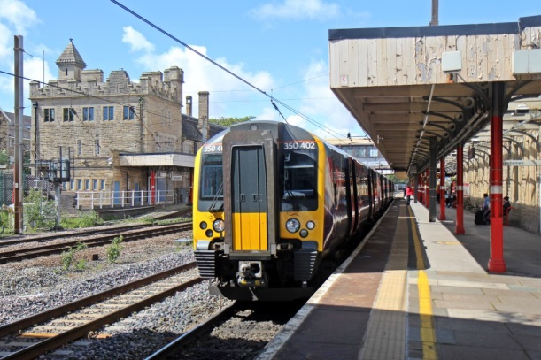
Hebden Poetry Enjoy
Friends of
Station
Hebden Bridge
Platform 3 Lancaster Railway Station
Like dogs on leash here come the trundlers leading their cases,
stressed parents with toddlers feeding dribbling faces,
shapely legged cyclists in Lycra with bikes,
walkers with haversacks looking forward to hikes
round the coastline or up to the lakes.

And then there are teens ear-plugged-in but switched off
from all their surroundings – and if that’s not enough –
the boyfriends and girlfriends with lips locked together
saying temporary goodbyes as if it’s forever.

There are those who are staying a weekend or more
and those out for the day for the sea and the shore
with buckets and spades, beach balls and windbreaks
and towels and swimsuits and all that it takes
to have a good time – but prepare for the worst –
in case the weather turns cold or there is a cloudburst.
Yes, we’re all off to Morecambe, and here comes the train.
We rush to the doorways – but rushing’s in vain
‘cos it’s packed to the ginnels with folks coming back.
They’re alighting in hundreds which inspires a wise-crack -
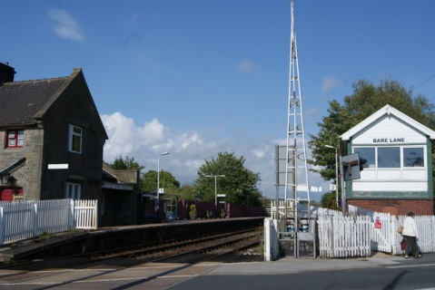
as they keep piling off this guy says “just look
I think it’s been an attempt to get into that book –
you know the one with the records, that’s what it is.”
It empties, we’re on, never known it like this.
We’re actually off now – next stop is Bare Lane –
can hear someone saying “how did that get its name?”

Morecambe is here where I catch a bus to my mothers.
I stand at the stop along with four others.
An elderly lady, first in the queue, sees a bus coming close,
“Not in Service” she reads and then, “I suppose that’s where
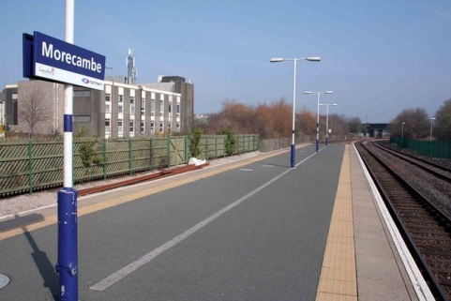
I’d better move – more buses go there than anywhere else.”

Ah the Northern humour.

Anne Etherington A Lancastrian passionate about the arts - loving the cinema
link in Hebden Bridge that allows greater access to live theatre, opera and ballet.
Anne is an artist and taught art in secondary schools in Lincolnshire before
moving on impulse to Hebden Bridge. She attempts to create mood and atmosphere
in her poetry and finds inspiration for writing from people, personal experiences and the natural landscape.

